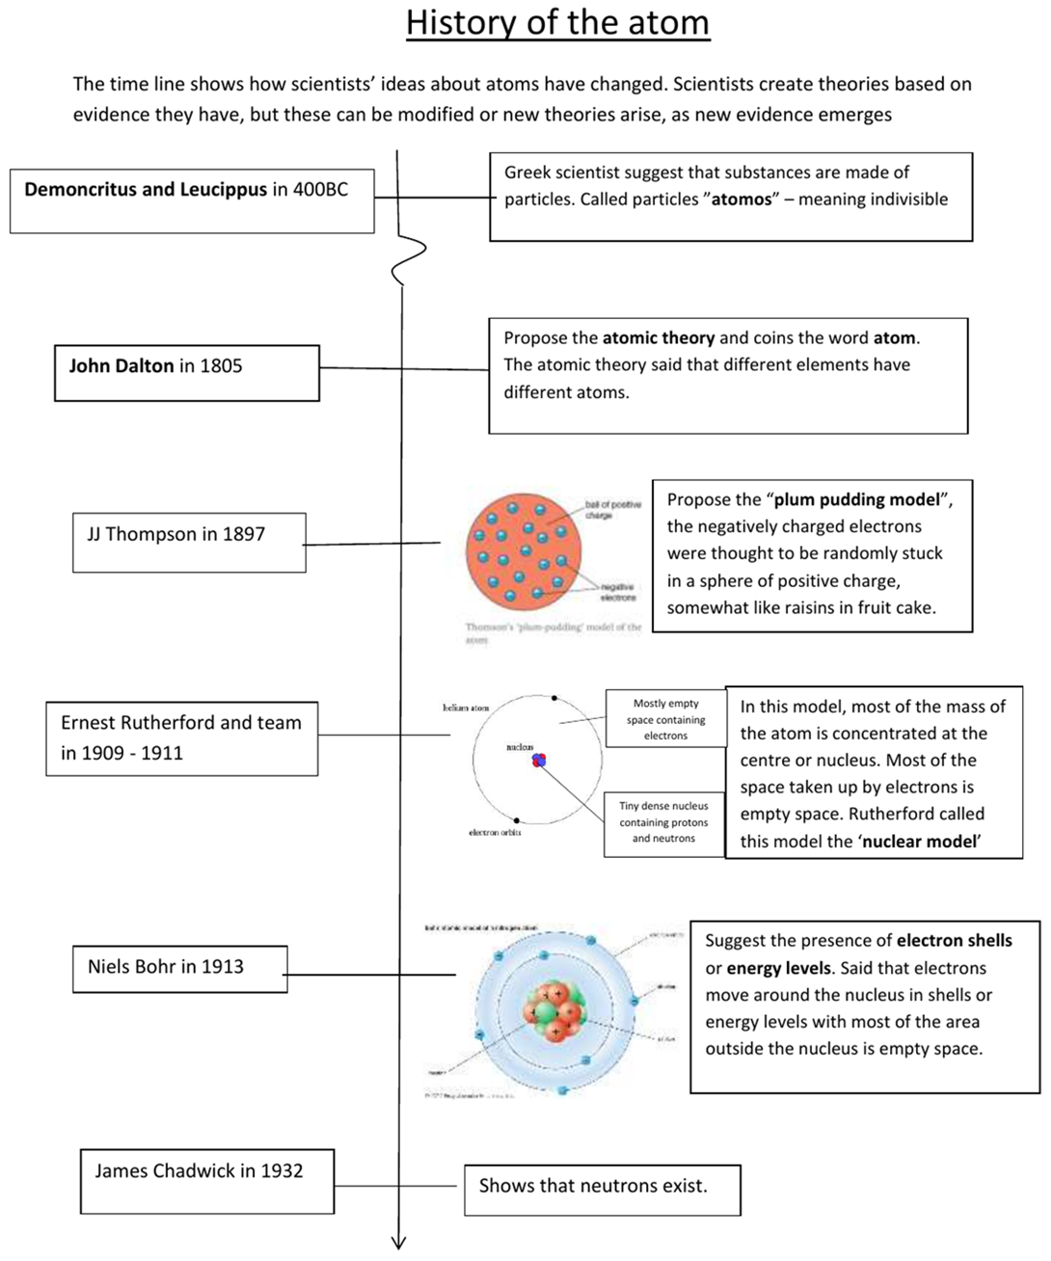
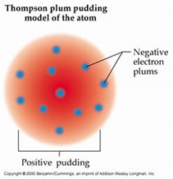
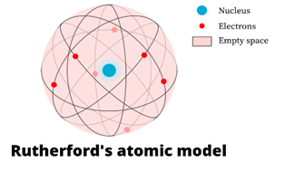
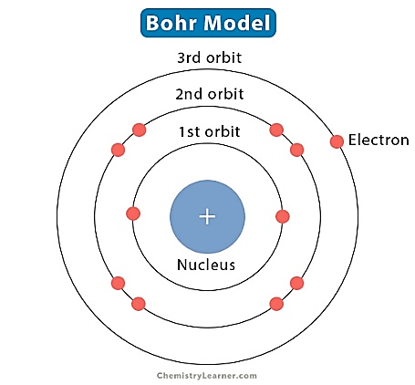
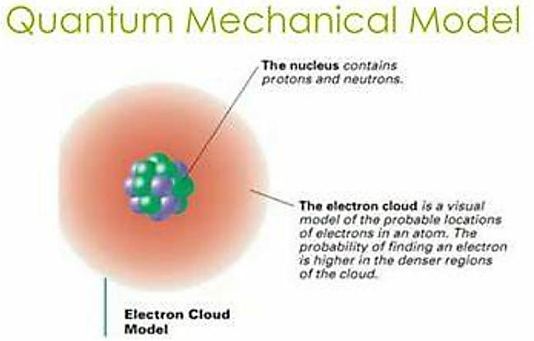

MODELS of the atom
_________________ 1. Suggested that the electrons in an atoms have to move around in certain regions of space called shells.
_________________ 2. Proposed that all things are made up of tiny solid particles.
_________________ 3. Proposed the idea of the nucleus. This nucleus contains all the mass of the atom and all the positive charges, with the very light electrons moving around outside the nucleus.
_________________ 4. Proposed that the movement of electrons cannot be predicted, and that the position of the electrons within a region of space can only be described by mathematical probability.
_________________ 5. Proposed the presence of a “heavy” uncharged particle in the nucleus, calls it the neutron.
_________________ 6. Proposed that an atom was a ball of positive charge with the negatively charged electrons distributed throughout the ball.
_________________ 7. Proposed that all matter is made up of atoms, with the different elements being made of different atoms. Materials which were not elements, were made of different combinations of the atoms that made up the elements.

